SHAHEED BHAGAT SINGH STATE TECHNICAL CAMPUS
Moga Road, NH-95, Ferozepur -152004
(Established by the Punjab Government)
(Formerly Shaheed Bhagat Singh College of Engineering & Technology)

STORE AND PURCHASE SECTION
Manual for performing operations in PnI application of TCSiON
(For Central Store)

Table of Content

Sr no | Topic | Page No
1 | Request for issue of items from Central Store by deptt.  (Dept. -> CS) (RAISE INDENT) | 2
2 | Issue of items from the Central Store to deptt. in TCSiON | 3
3 | Purchase process of Items by the Central Store in TCSiON
3.1 | Raising Purchase Requisition (PR) for new items in TCSiON | 4
3.2 | Quotation Management in TCSiON | 5
3.3 | Purchase Order (PO) for new items in TCSiON | 6
3.4 | Good Receipt Note (GRN) for item in TCSiON | 7
4 | Procedure for repair/service of equipments in TCSiON | 8

Abbreviations used: IO -> Indent Originator, DSPO -> Dept. Store & Purchase Officer

- Request for issue of items by dept. from the central store (RAISE INDENT)
  - Workflow
IO ->HoD -> Rampal
  - Dept IO will raise indent
Click
-> Procurement and inventory -> inventory -> Raise Indent - > Create
Select Source Site as respective Department.
Destination Site as EW (for central store)
  - HoD can approve/reject the indent raised by IO.
  - After approval from HoD, Indent will move to the Central Store (Mr Rampal).
  - Mr Rampal will issue items if available, otherwise purchase process will be initiated by Mr Rampal.
  - After completing the purchase process, Mr Rampal will issue items to the IO of dept.
  - IO can further issue or consume items to staff members of deptt.
by clicking
-> Procurement and inventory -> inventory -> Consumption & Issue- > Create

- Issue of items from the Central Store to deptt. in TCSiON
(To be done by Mr Rampal)

    - Mr Rampal will issue item from the store
Click
-> Procurement and inventory -> Inventory -> Dispatch- > Indent based Dispatch.
    - Indent Raiser will be notified about issue of items from the store.
    - Indent Raiser will accept the items issued.

- Purchase process of Items by the Central Store in TCSiON
  - Raising Purchase Requisition (PR)
    - Workflow
Rampal -> SPO -> Registrar -> Director
    - Mr Rampal will initiate the PR
Click
-> Procurement and inventory -> Precurement -> Purchase Requisition - > Create
    - After Submission, it will move to SPO.
SPO can approve/reject the PR
    - After approval from SPO, PR will move to login of the Registrar
The Registrar can approve/reject the PR
    - After approval from the Registrar, PR will move to login of the Director
The Director can approve/reject the PR.

  - Quotation Management in TCSiON
- Workflow
Rampal -> Rampal -> SPO -> Director
- Mr Rampal will initiate the Quotation process (Manual Quotations)
Click
-> Procurement and inventory -> Precurement -> Quotation Management - > Approve Vendor Quote
- Mr Rampal will approve/reject himself.
- After Submission, it will move to SPO.
SPO can approve/reject the Quotations Vendor Quote.
- After approval by SPO, Quotations Vendor Quote will move to login of the Director
The Director can approve/reject the Quotations Vendor Quote.

  - Purchase Order (PO) for new items in TCSiON
- Workflow
Rampal -> Rampal -> SPO
- Mr Rampal will initiate the PO
Click
-> Procurement and inventory -> Precurement -> Purchase Order - > Create
- Mr Rampal will approve/reject himself.
- After Submission, it will move to SPO.
SPO can approve/reject the PO.

  - Good Receipt Note (GRN) for item in TCSiON
- Workflow
Rampal -> SPO
- Mr Rampal will initiate the GRN
Click
- > Procurement and inventory - > Inventory - > Inwards - > GRN - > Create
- Mr Rampal will scan and upload Inspection Note.
- After Submission, it will move to SPO.
- SPO can approve/reject the GRN.
The inventory will be updated after approval by SPO.

- Procedure for repair/service of equipments in TCSiON
For repair/service of equipments, the process will be similar to purchase process for item except few changes.
General procedure for repair/service of Items by the Central Store in TCSiON will involve:
  - Raising Purchase Requisition (PR) for repair/service in TCSiON
  - Quotation Management in TCSiON
  - Purchase Order (PO) for repair/service in TCSiON
  - Good Receipt Note (GRN)
The procedure for repair/service will be similar as described for items in section 3 except following changes:

While raising PR, select services instead of items as shown below:
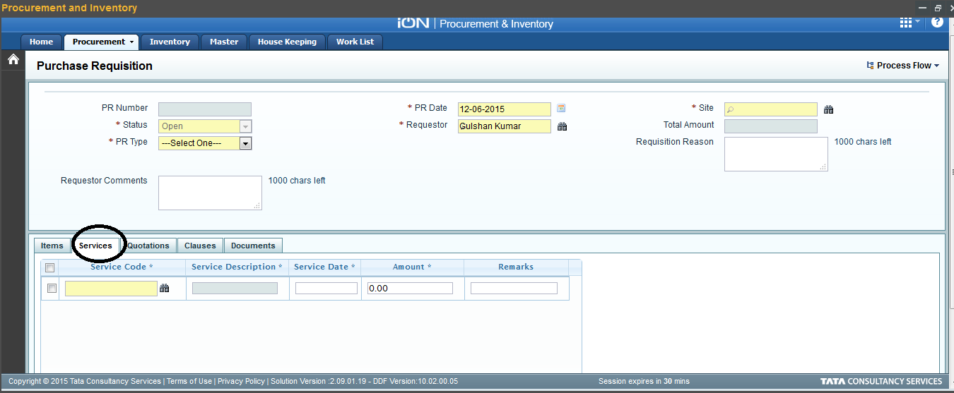

While raising PO, select services instead of items as shown below:
